**Loading the Dataset tables from ZIP File (i.e TAR file)**

**Open this Link to access dataset zip file**

[**https://github.com/saikiran123456/postgreSQL_pgAdmin4_Pyscopg2/tree/master/Python%2BPosrgreSQLconnection/dvdrental(ImportingDB%26Doing35analysis)**](https://github.com/saikiran123456/postgreSQL_pgAdmin4_Pyscopg2/tree/master/Python%2BPosrgreSQLconnection/dvdrental(ImportingDB%26Doing35analysis))

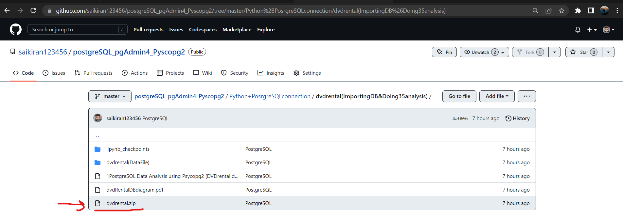

**Download this Zip/Tar file:**

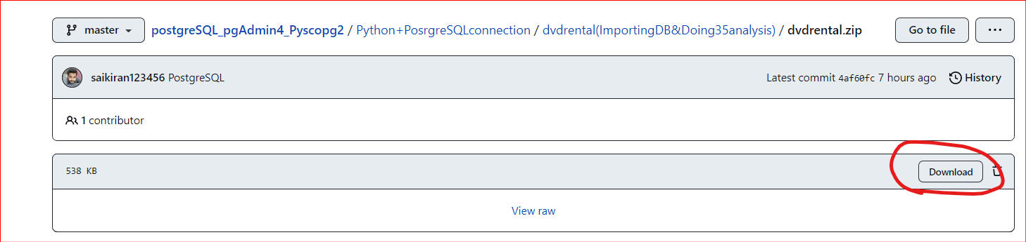

**Save it in your location**

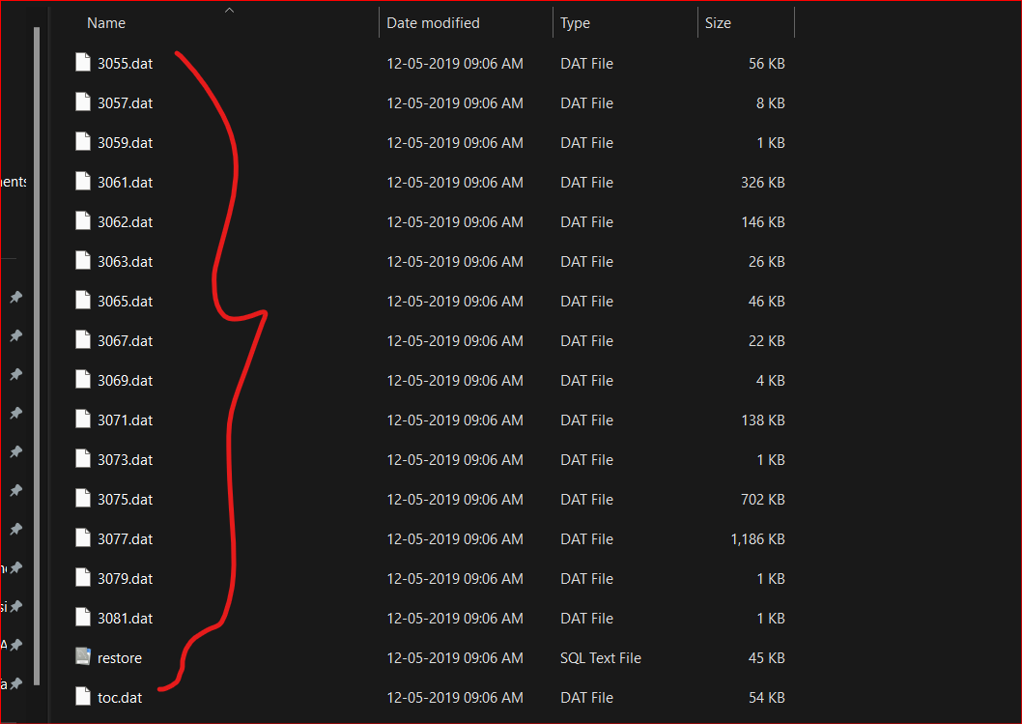

**Open Your pgAdmin4 Interface:**

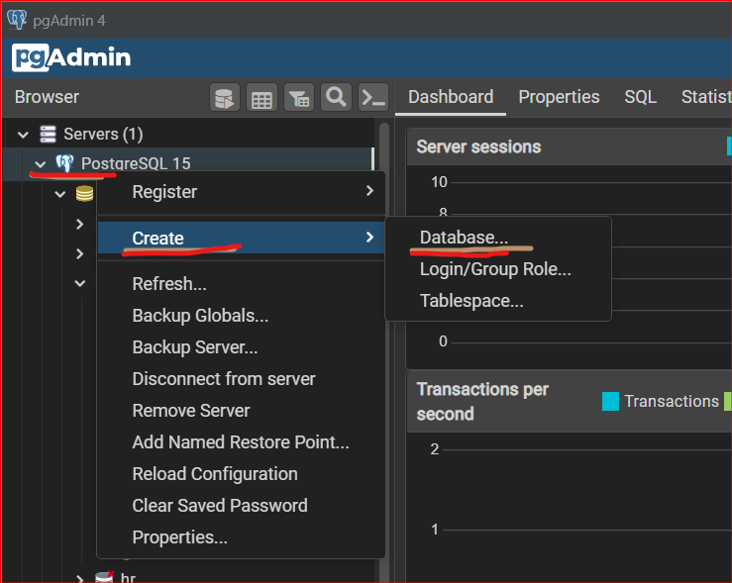

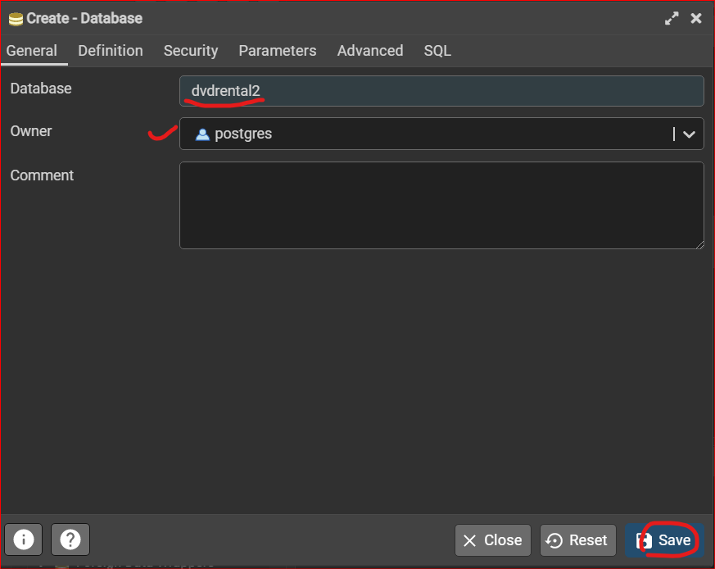

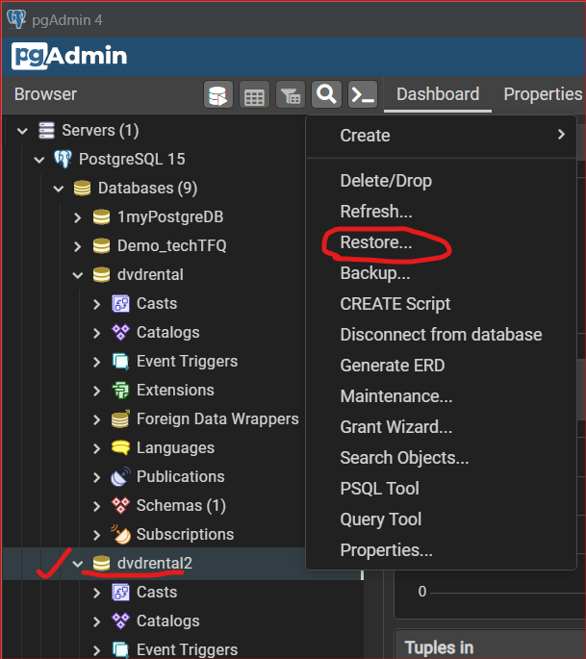

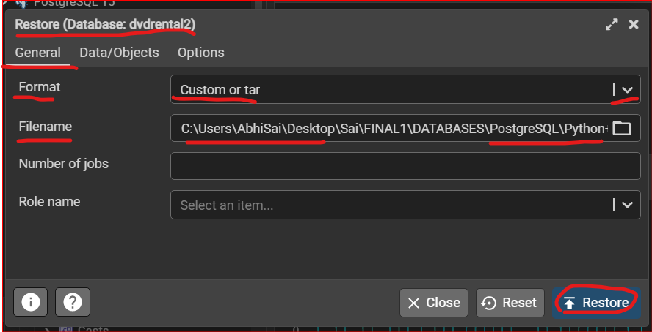

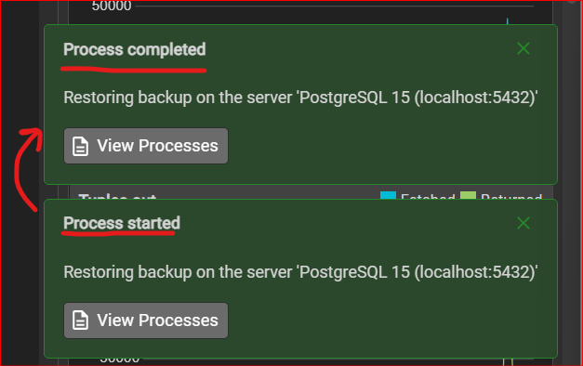

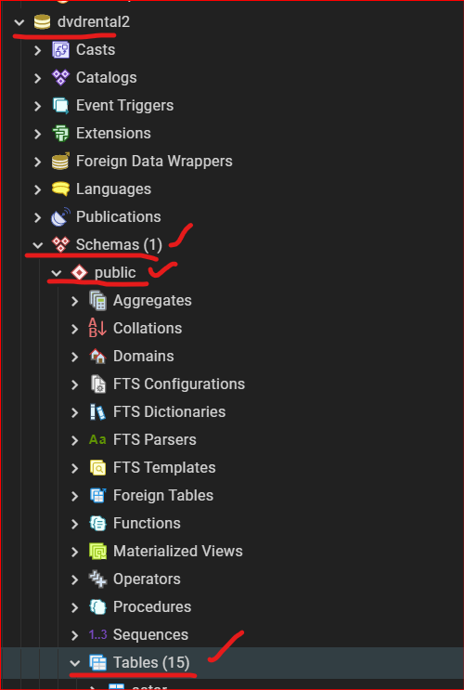

**These are all the Tables inside the ZIP file**

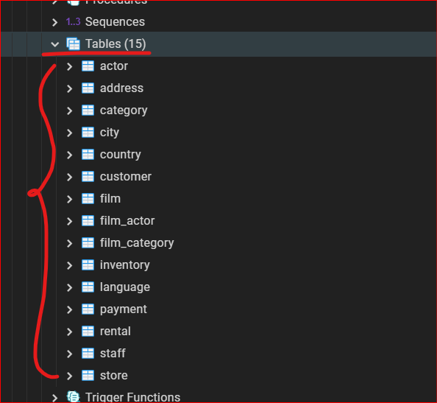

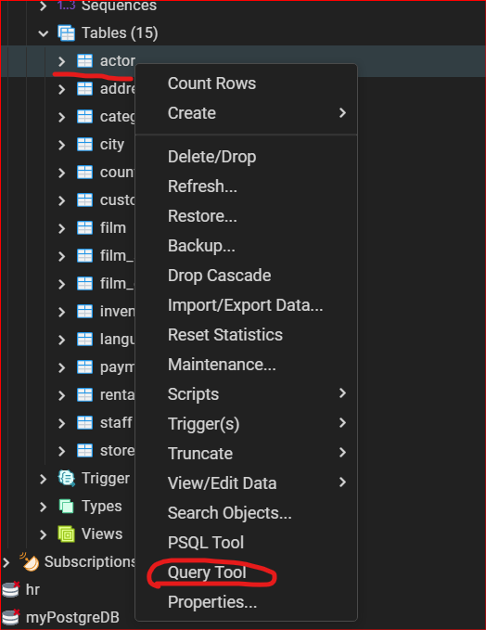

**Output of Actor Table**

